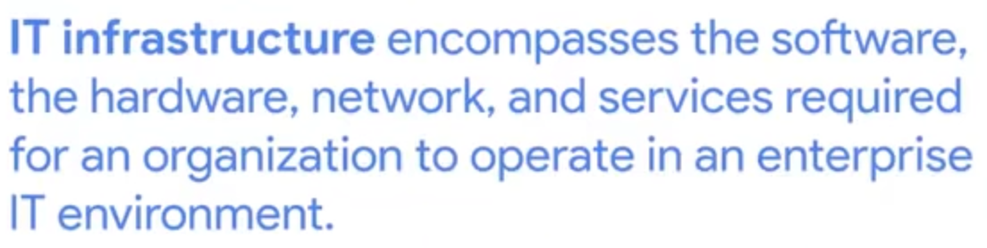

Types of Servers: 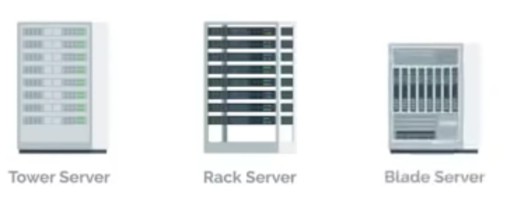

KVM Switch: Keyboard, Video and Mouse 🡺 You can connect more pc/servers and manage them with only a Keyboard and Mouse

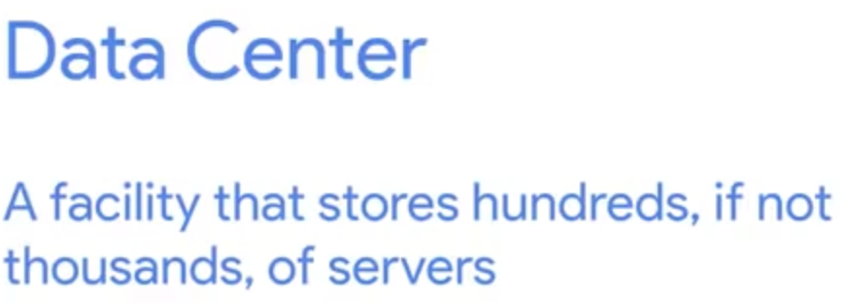

User and Hardware Provisioning 🡺 Managing, giving and removing rights to user and hardware

Batch Update 🡺 Every 1 Month you run updates on all the servers/services

IT-Infrastructure Services 🡺

Infrastructure as a Service 🡺 To use cloud services for Infrastructure

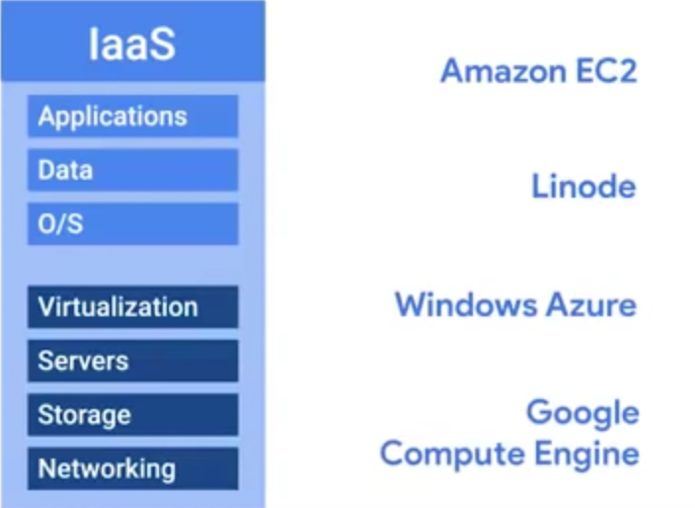

Naas 🡺 Network as a service, Cloud Service for Networking

Saas 🡺 Software as a Service

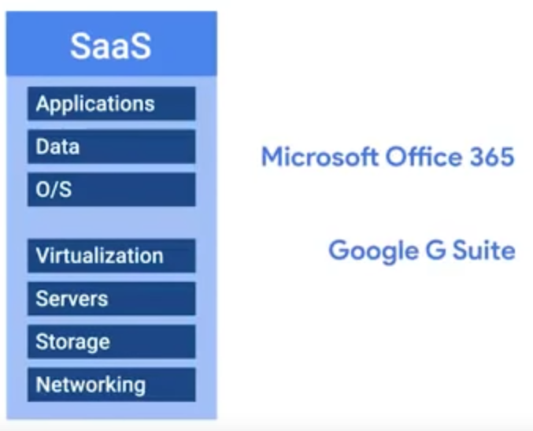

Platform as a service 🡺 Platform as a service (PaaS) is a complete development and deployment environment in the cloud, with resources that enable you to deliver everything from simple cloud-based apps to sophisticated, cloud-enabled enterprise applications. PaaS includes infrastructure—servers, storage, and networking—but also middleware, development tools, business intelligence (BI) services, database management systems

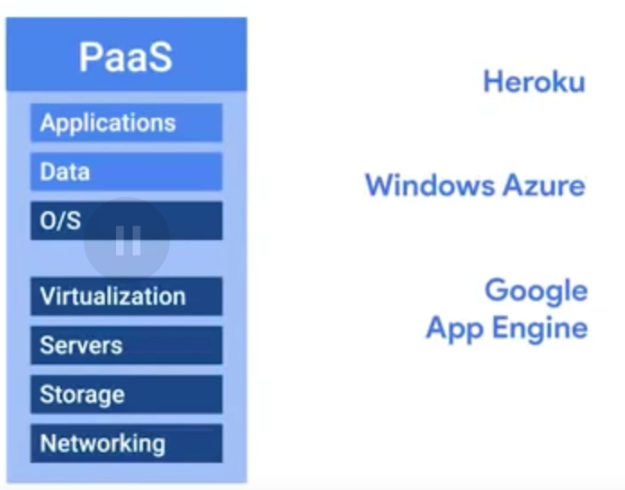

Directive Services🡺 Managing users and their rights (DaaS) Directive as a Service

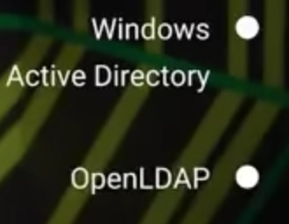

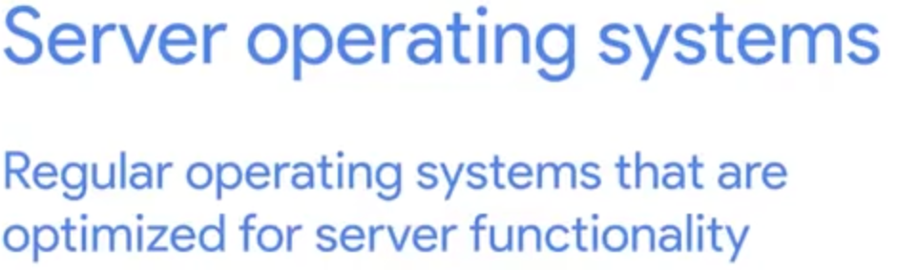

**Server virtualization** is the process of creating multiple server instances from one physical server. Each server instance represents an isolated virtual environment. Within each virtual environment, you can run a separate operating system.

OpenSsh: remote control of Server. HOW:

Install OpenSSH Server in the Server(listens to incoming ssh connection), and OpenSSH-Client in the client machine.





Ssh hostname@ip_address

For Windows 🡺 Windows Access Remote Tools

FTP File Transfer Protocol.

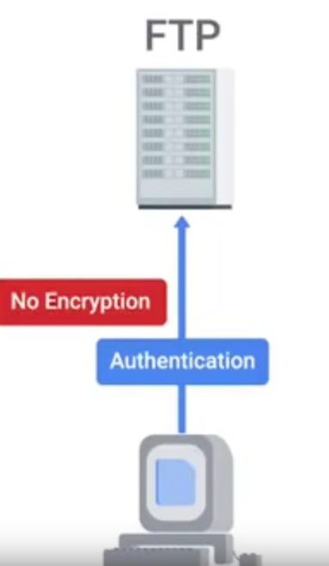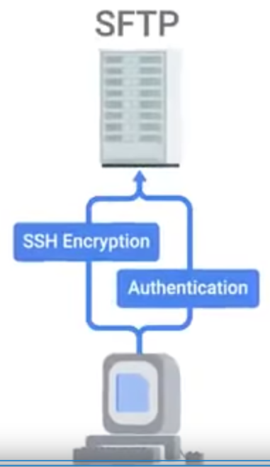

PXE Boot (Pre execution Environment) is a method of having an end computer (client) boot using only its network card

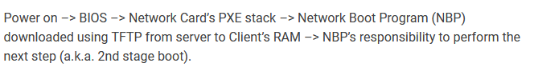

NTP 🡺 Network Time Protocol (WICHTIG!)

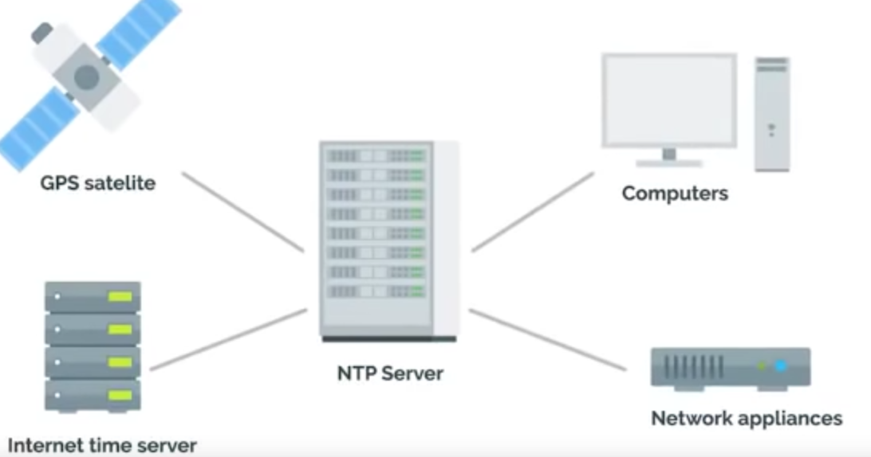

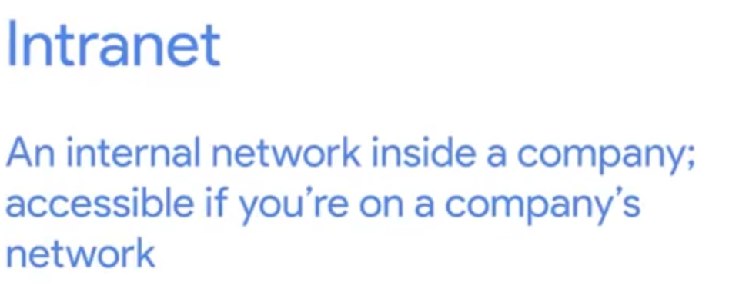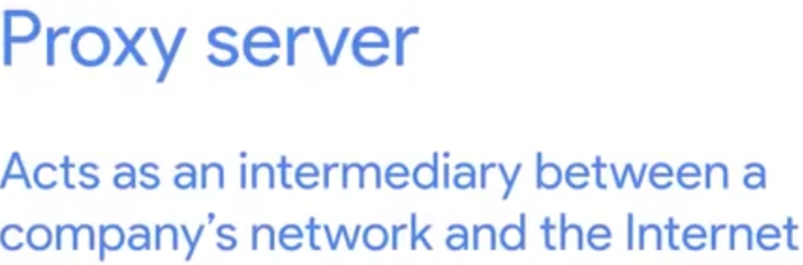

DNS 🡺 Domain Name System!!!!

How to

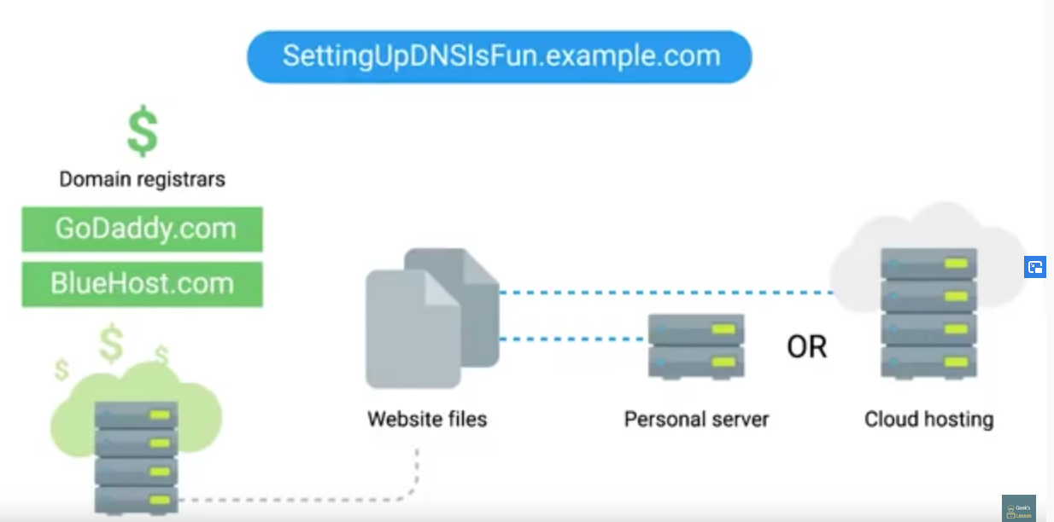

/etc/hosts 🡺 file, where DNS queries are saved

**Software Services**:

Communication Servies 🡺 IRC / Slack unsw

Email Services 🡺

POP3 🡺 It downloads the content from the Server than deletes it from the Server (Weniger Storage and Security)

IMAP 🡺 Allows to download emails from Email-Server from multiply email devices.

SMPT 🡺 Protocol used to send emails

**Files Services** 🡺

Files Storage Server 🡺 Manage Store and save Files in the Server

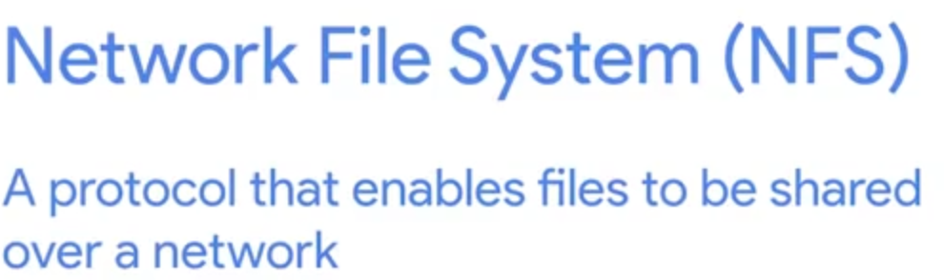

Samba Services 🡺 More compatible with windows. SMB is the protocol that SAMBA uses.

NAS 🡺 Network Attached Storage 🡺 Computers, attached with a lot of Storage to save files, and use an OS, that is stripped down for minimal usage.

**Print Services** 🡺

CUPS 🡺 For UNIX

**Platform Services** 🡺 provide a platform for Developers to develop software.

Apache HTTP Server

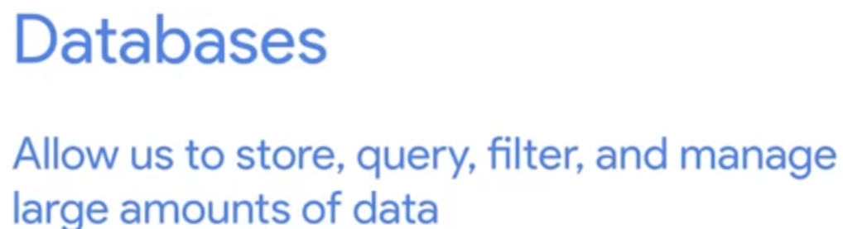

MySQL

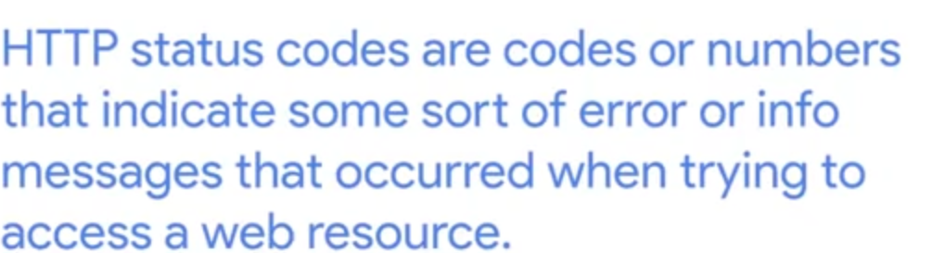

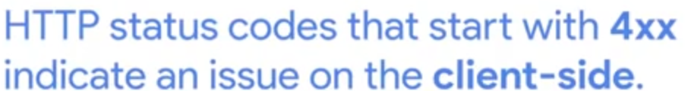

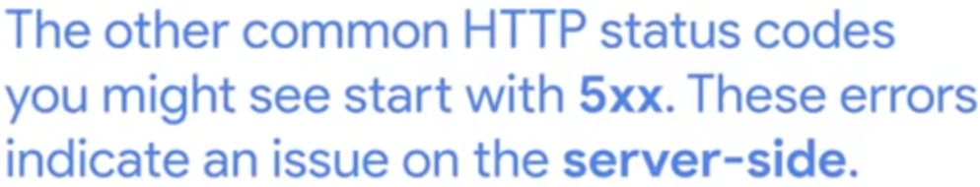

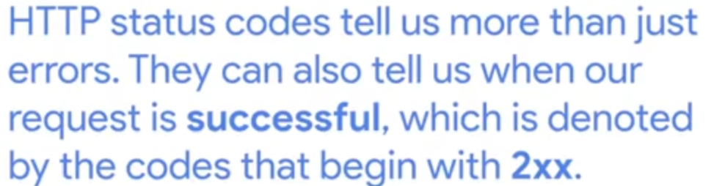

In Developer Mode, in Network Section, in Google, we can check the status of the website

**Directory Services** 🡺

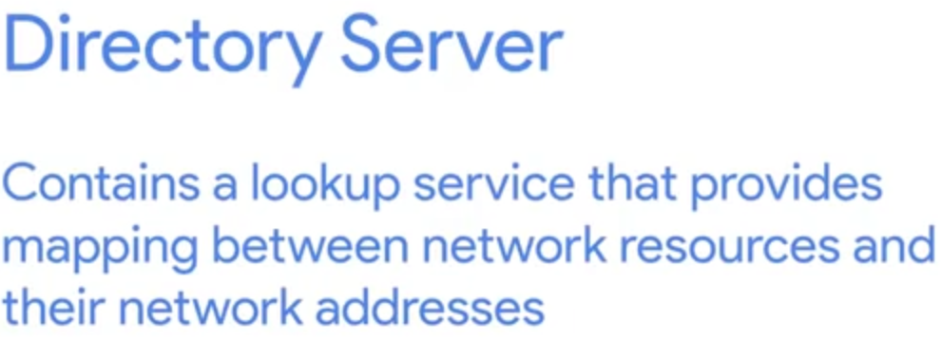

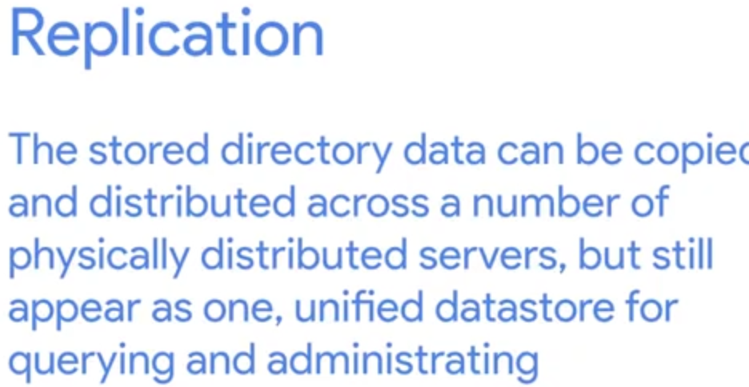

OU = Organizational Units == a container

Directory Access Protocol = **DAS**

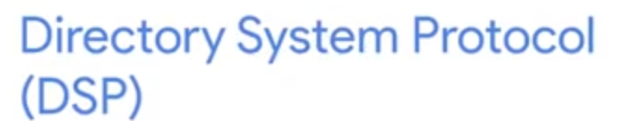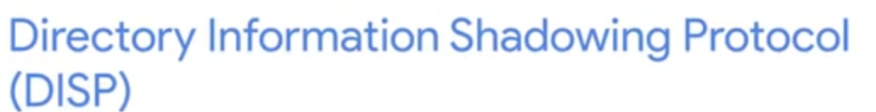

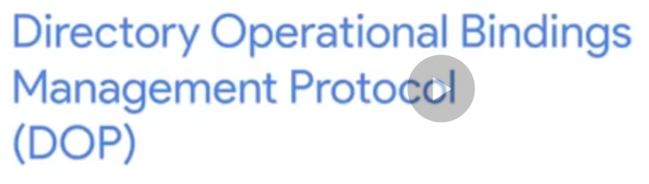

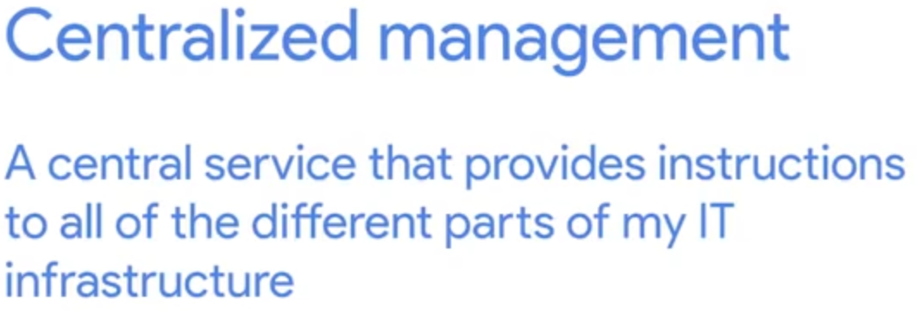

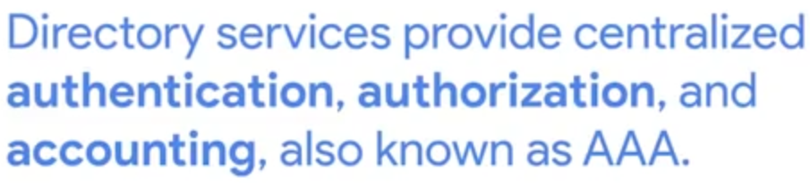

LDAP 🡺 Lightweight Directory Access Protocol

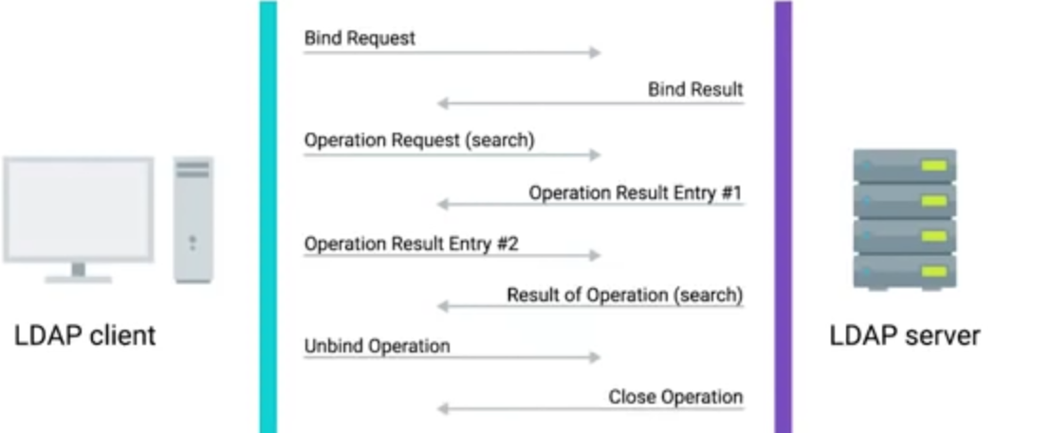

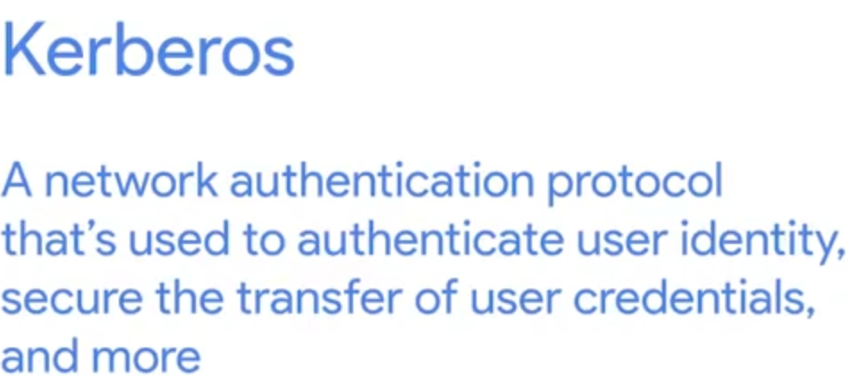

Active Directory 🡺 native Directory Service for Windows

ADAC🡺 Active Directory Administrator Service

DCs 🡺 Domain Controllers

Join Computer in the AD🡺

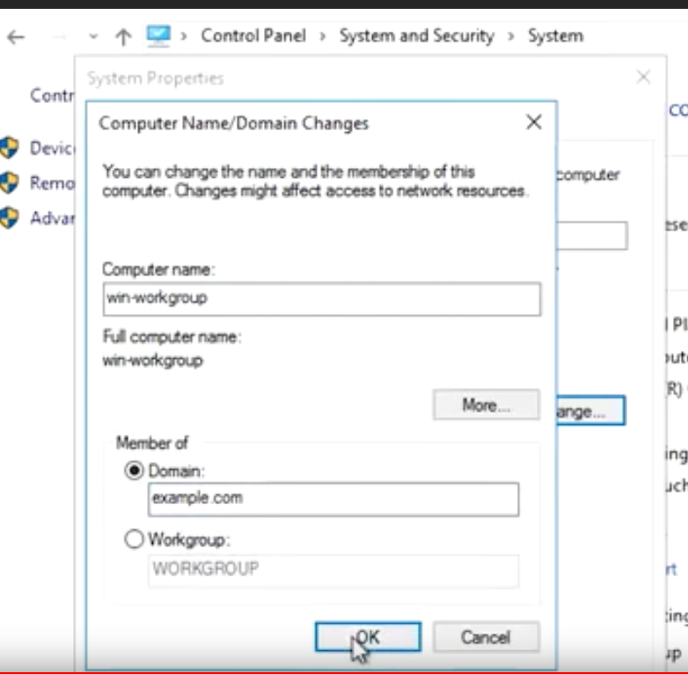

After we press OK, it will prompt a Authentication Process. We should Authenticate with a Domain Account

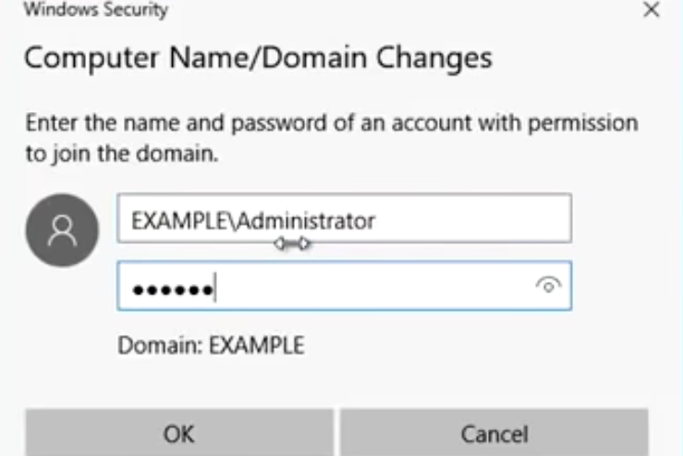🡺 It requires a Reboot

VIA Powershell: 

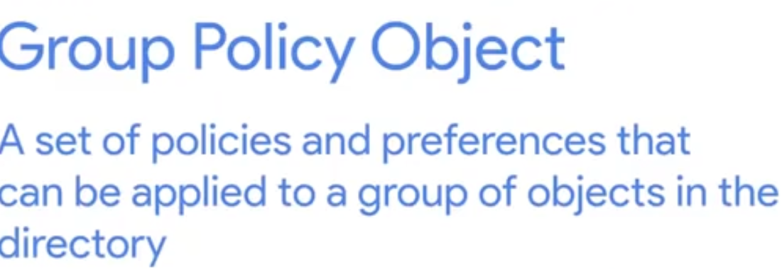GPO

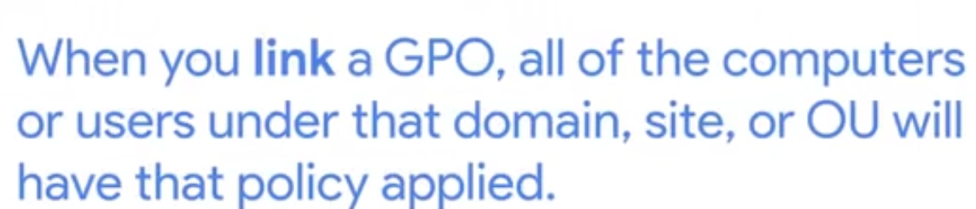

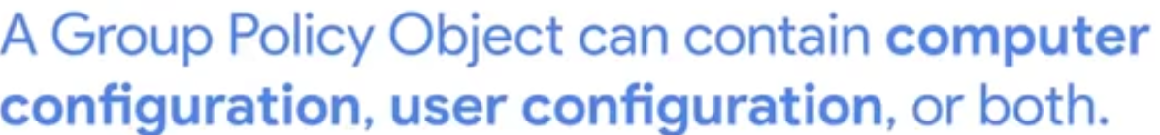

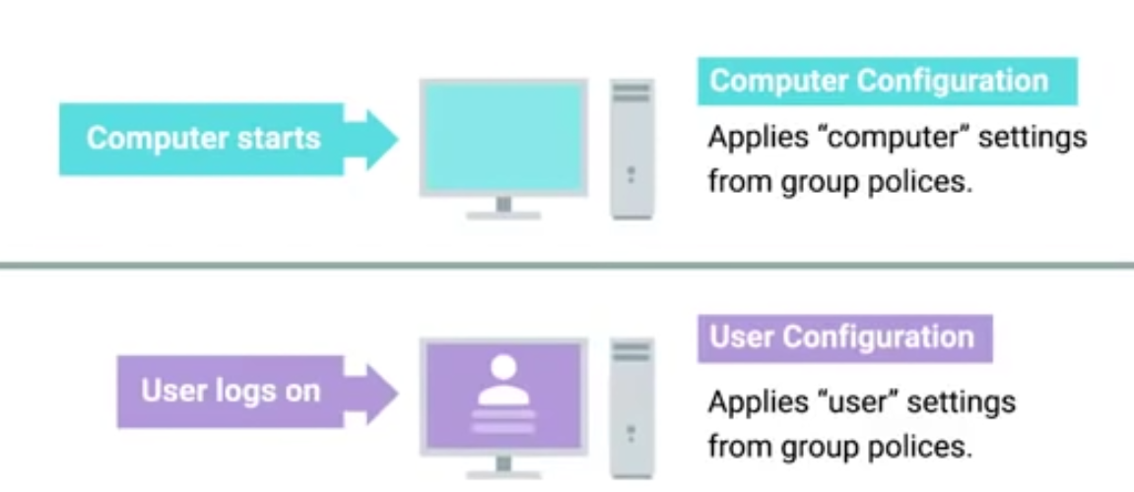

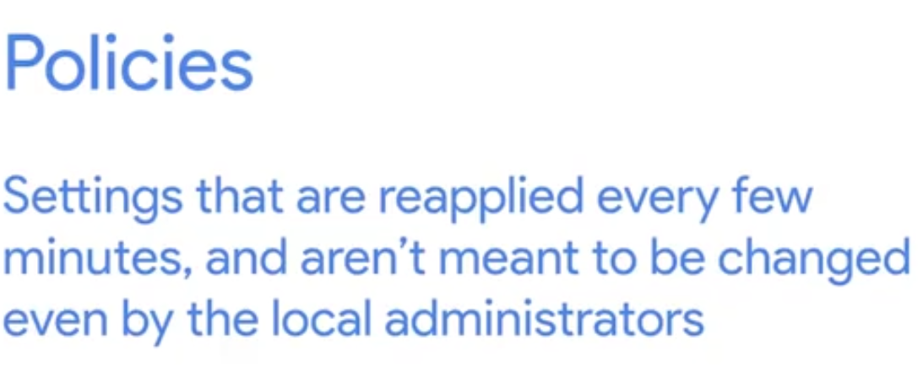

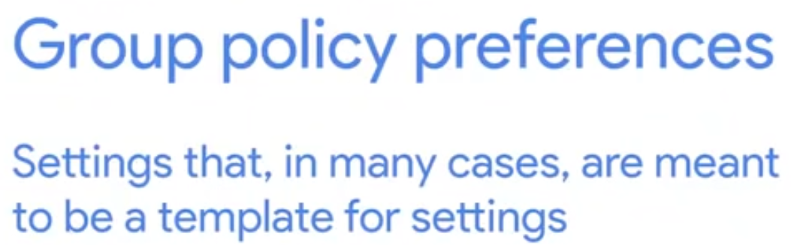

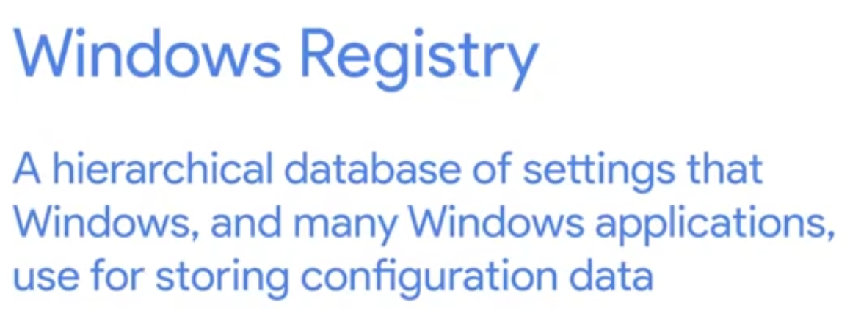

GPMC 🡺 Group Policy Management Console ( We can find it under Control Management in Windows Server)

We can BackUp the GPO. Einfach Right Click in the Group Policy Objects and than click Back Up.

Group Policy Troubleshooting Tools 🡺

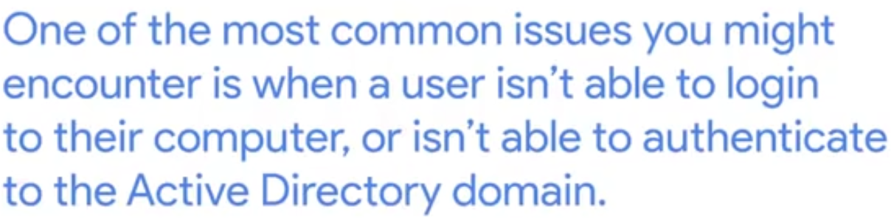

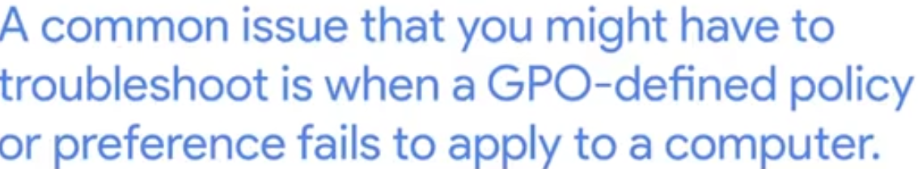

Befehl: gpupdate/force To force update

**OpenLDAP** 🡺

Manage LDAP via phpLDAP Admin

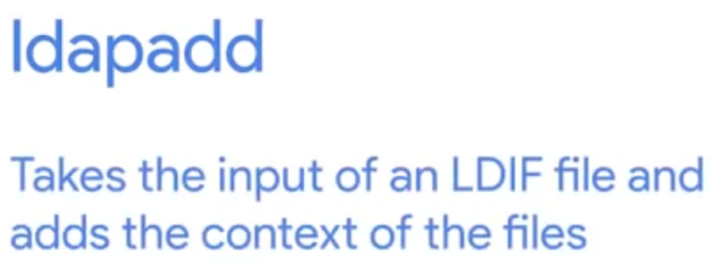

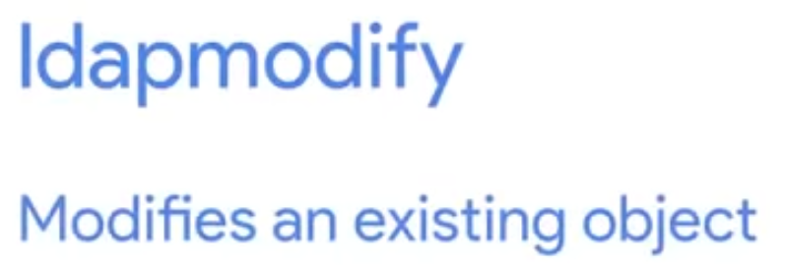

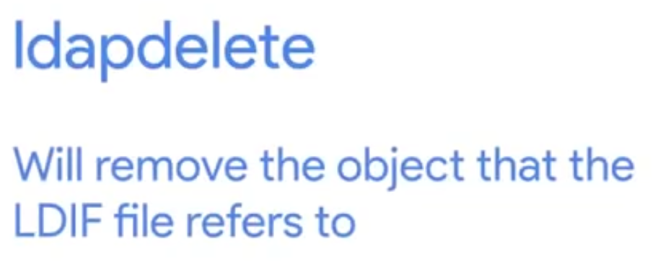

Ldapsearch Befehl too.

**Recovery and Backups**

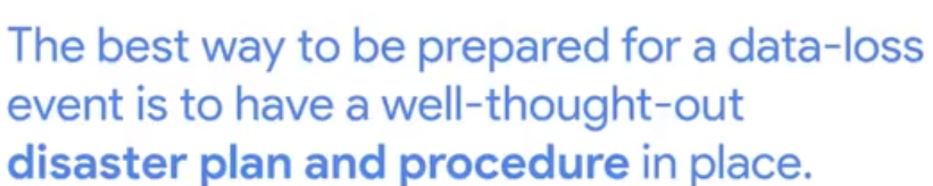

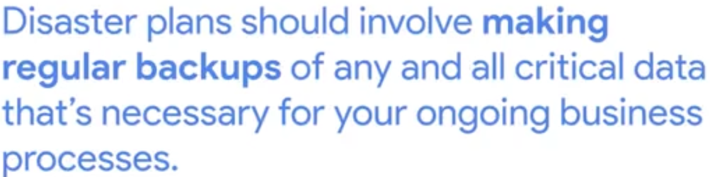

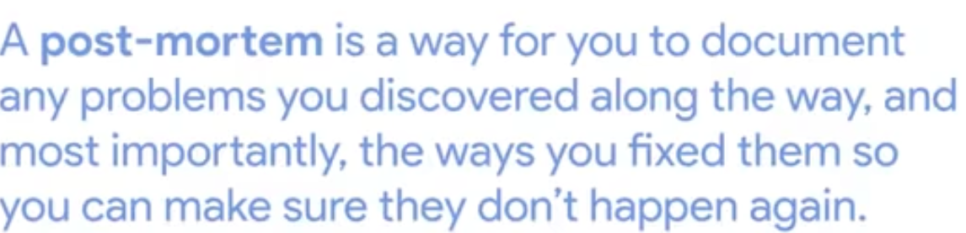

Backup Data

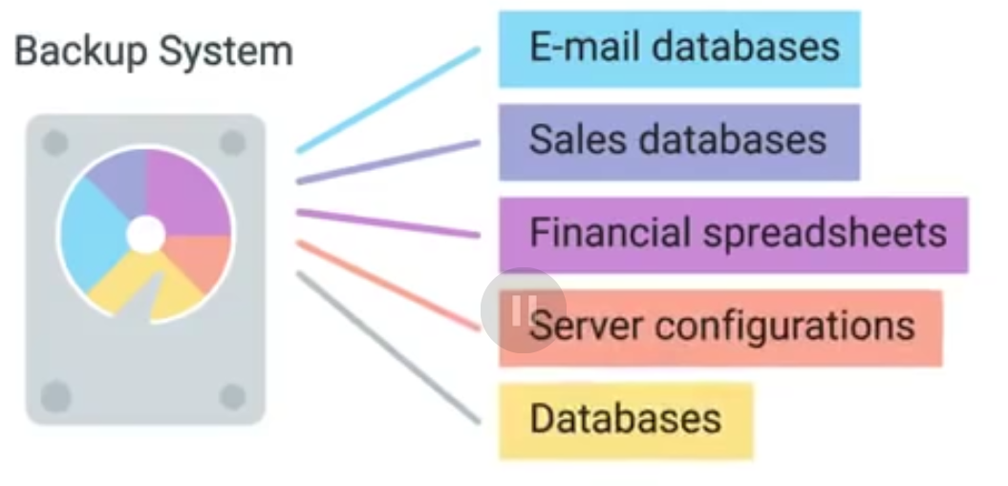

Backup Solutions 🡺

Rsync 🡺 command line tool

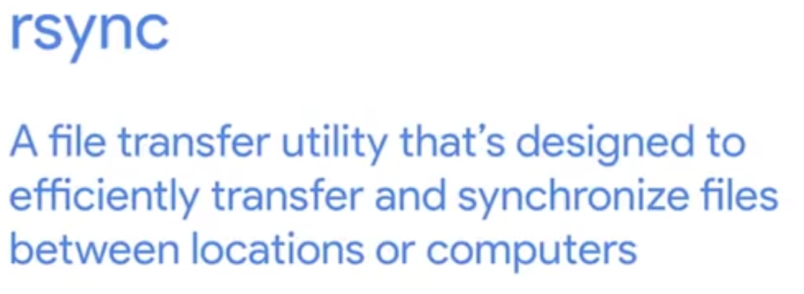

Time Machine 🡺 For Apple products

Backup and restore 🡺 Microsoft

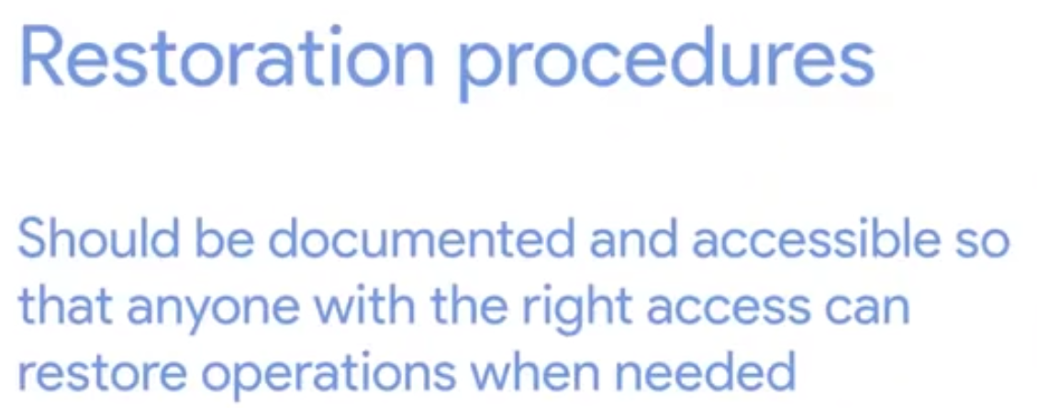🡺 The Backups should be tested!! == Disaster Recovery Testing

Ways to Backup :

Full Backup or Differential Backups(Backups only the files that are changed)

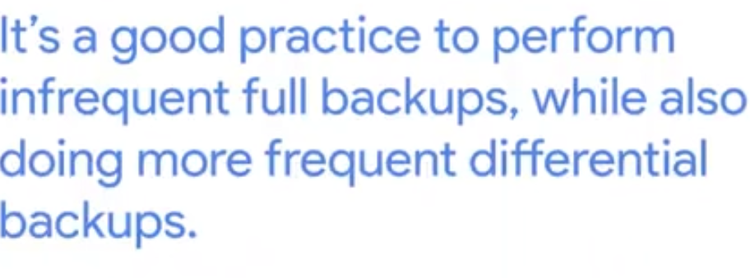

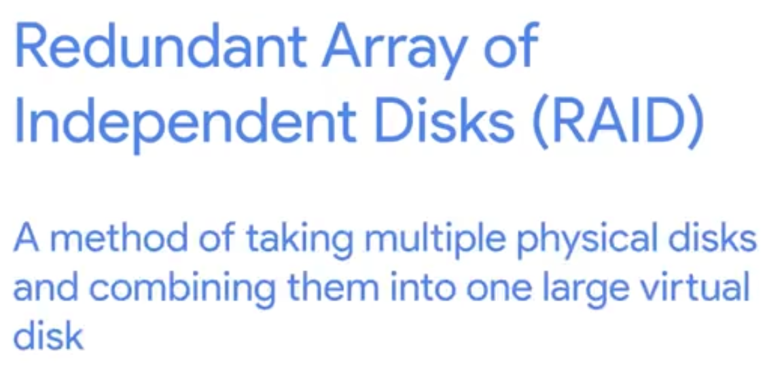

Users Backups 🡺 Cloud Service